HTML Iframe Element

📘 Definition
# Source: AI Source: Provided by: [Data Path: Persons Table -> ID Column: 1, Name_En Column: Motasem Essam] -> From: [ChatGPT] on [5/6/2026]
The HTML <iframe> element is used to embed another webpage or document inside the current webpage.
iframe means:
👉 Inline Frame

🧠 Common Uses of <iframe>
# Source: AI Source: Provided by: [Data Path: Persons Table -> ID Column: 1, Name_En Column: Motasem Essam] -> From: [ChatGPT] on [5/6/2026]
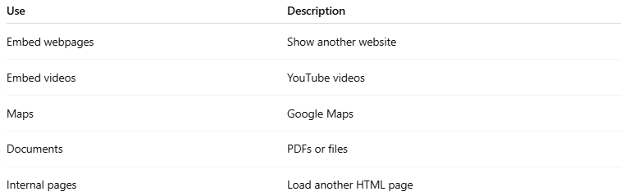
Use | Description
Embed webpages | Show another website
Embed videos | YouTube videos
Maps | Google Maps
Documents | PDFs or files
Internal pages | Load another HTML page

🌐 Basic Syntax
# Source: AI Source: Provided by: [Data Path: Persons Table -> ID Column: 1, Name_En Column: Motasem Essam] -> From: [ChatGPT] on [5/6/2026]
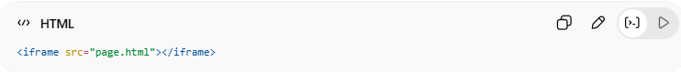
<iframe src="page.html"></iframe>
👉 Displays another page inside the frame

🔤 Common Attributes
# Source: AI Source: Provided by: [Data Path: Persons Table -> ID Column: 1, Name_En Column: Motasem Essam] -> From: [ChatGPT] on [5/6/2026]
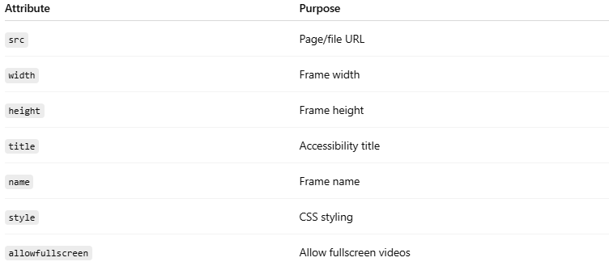
Attribute | Purpose
src | Page/file URL
width | Frame width
height | Frame height
title | Accessibility title
name | Frame name
style | CSS styling
allowfullscreen | Allow fullscreen videos

1. 🌍 Basic Iframe
# Source: AI Source: Provided by: [Data Path: Persons Table -> ID Column: 1, Name_En Column: Motasem Essam] -> From: [ChatGPT] on [5/6/2026]
📖 Description
Embeds another webpage.
💻 Example:
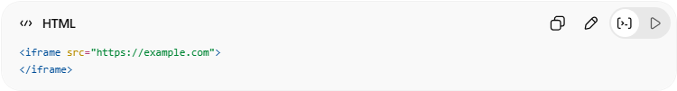
<iframe src="https://example.com">
</iframe>

2. 📏 Set Width and Height
# Source: AI Source: Provided by: [Data Path: Persons Table -> ID Column: 1, Name_En Column: Motasem Essam] -> From: [ChatGPT] on [5/6/2026]
📖 Description
Controls iframe size.
💻 Example:
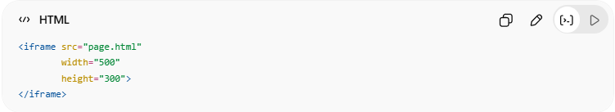
<iframe src="page.html"
width="500"
height="300">
</iframe>

3. 🎨 Remove Border
# Source: AI Source: Provided by: [Data Path: Persons Table -> ID Column: 1, Name_En Column: Motasem Essam] -> From: [ChatGPT] on [5/6/2026]
📖 Description
Removes default iframe border.
💻 Example:
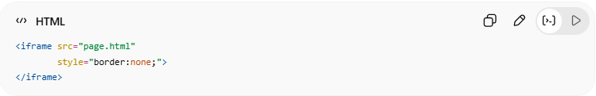
<iframe src="page.html"
style="border:none;">
</iframe>

4. 🎥 Embed YouTube Video
# Source: AI Source: Provided by: [Data Path: Persons Table -> ID Column: 1, Name_En Column: Motasem Essam] -> From: [ChatGPT] on [5/6/2026]
📖 Description
YouTube videos commonly use iframes.

💻 Example:
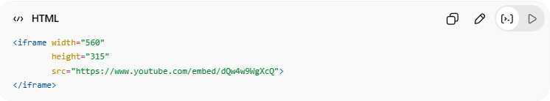
<iframe width="560"
height="315"
src="https://www.youtube.com/embed/dQw4w9WgXcQ">
</iframe>

5. 🎯 Use target with Iframe
# Source: AI Source: Provided by: [Data Path: Persons Table -> ID Column: 1, Name_En Column: Motasem Essam] -> From: [ChatGPT] on [5/6/2026]
📖 Description
Links can open pages inside a named iframe.
💻 Example:
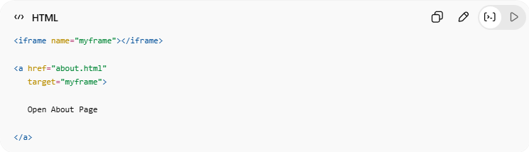
<iframe name="myframe"></iframe>
<a href="about.html"
target="myframe">
Open About Page
</a>
👉 Link opens inside iframe

💻 Example

Full Example

about.html
# Source: AI Source: Provided by: [Data Path: Persons Table -> ID Column: 1, Name_En Column: Motasem Essam] -> From: [ChatGPT] on [5/6/2026]
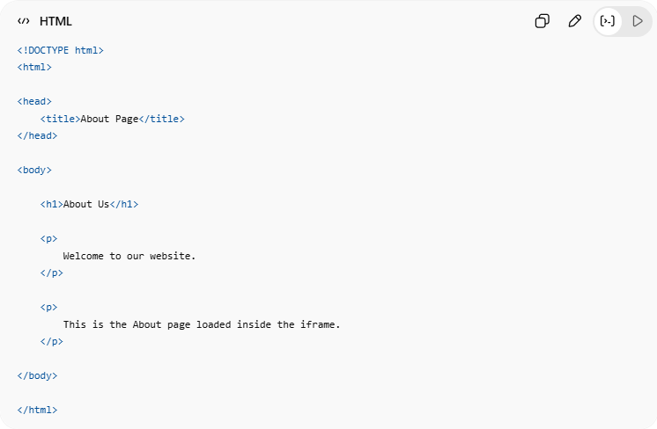
<!DOCTYPE html>
<html>

<head>
<title>About Page</title>
</head>

<body>

<h1>About Us</h1>

<p>
Welcome to our website.
</p>

<p>
This is the About page loaded inside the iframe.
</p>

</body>

</html>

Index.html
# Source: AI Source: Provided by: [Data Path: Persons Table -> ID Column: 1, Name_En Column: Motasem Essam] -> From: [ChatGPT] on [5/6/2026]
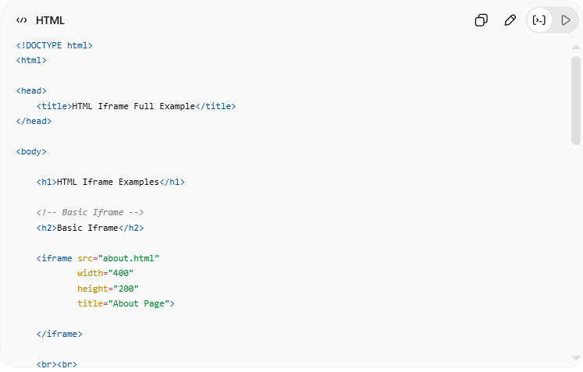
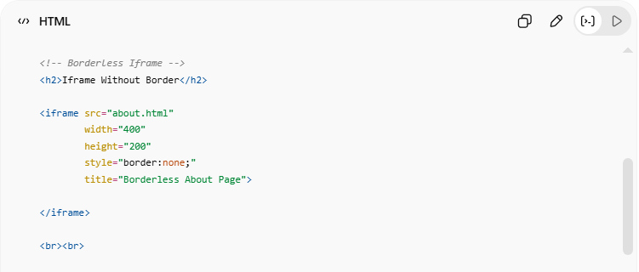
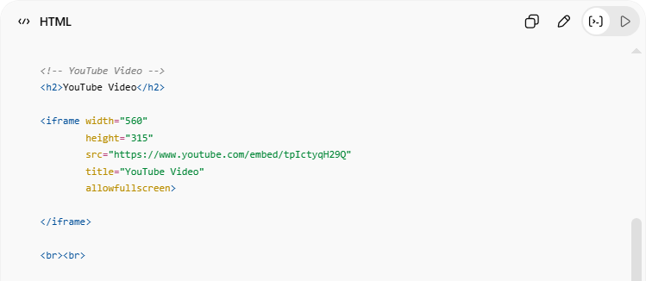
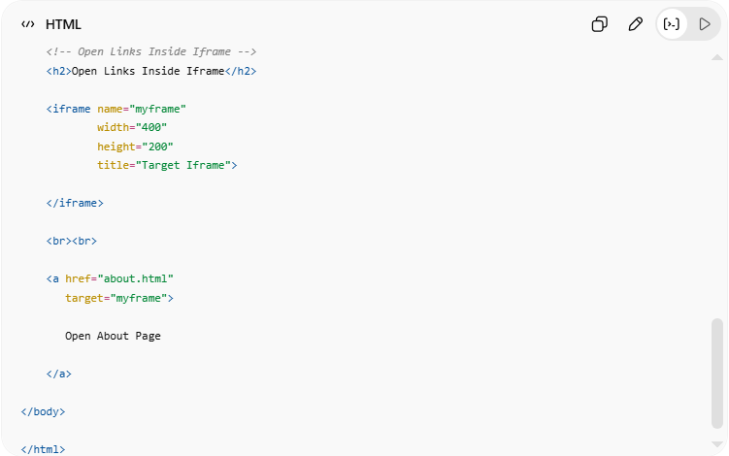
<!DOCTYPE html>
<html>

<head>
<title>HTML Iframe Full Example</title>
</head>

<body>

<h1>HTML Iframe Examples</h1>

<!-- Basic Iframe -->
<h2>Basic Iframe</h2>

<iframe src="about.html"
width="400"
height="200"
title="About Page">

</iframe>

<br><br>

<!-- Borderless Iframe -->
<h2>Iframe Without Border</h2>

<iframe src="about.html"
width="400"
height="200"
style="border:none;"
title="Borderless About Page">

</iframe>

<br><br>

<!-- YouTube Video -->
<h2>YouTube Video</h2>

<iframe width="560"
height="315"
src="https://www.youtube.com/embed/tpIctyqH29Q"
title="YouTube Video"
allowfullscreen>

</iframe>

<br><br>

<!-- Open Links Inside Iframe -->
<h2>Open Links Inside Iframe</h2>

<iframe name="myframe"
width="400"
height="200"
title="Target Iframe">

</iframe>

<br><br>

<a href="about.html"
target="myframe">

Open About Page

</a>

</body>

</html>

Real Example

about.html
# Source: ScreenShot Source: Provided by: [Persons Table -> ID Column: 1, Name_En Column: Motasem Essam] -> Tool: [Automation Table -> ID Column: 16, Name_En Column: Screen Capture] -> From [Operating System: Windows] on [5/6/2026]
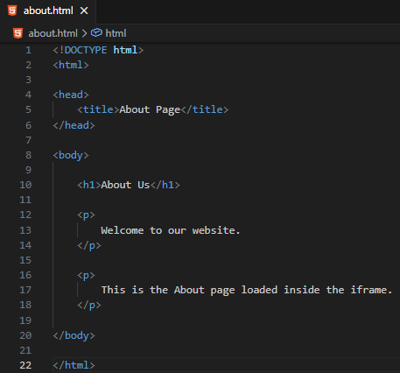
<!DOCTYPE html>
<html>

<head>
<title>About Page</title>
</head>

<body>

<h1>About Us</h1>

<p>
Welcome to our website.
</p>

<p>
This is the About page loaded inside the iframe.
</p>

</body>

</html>
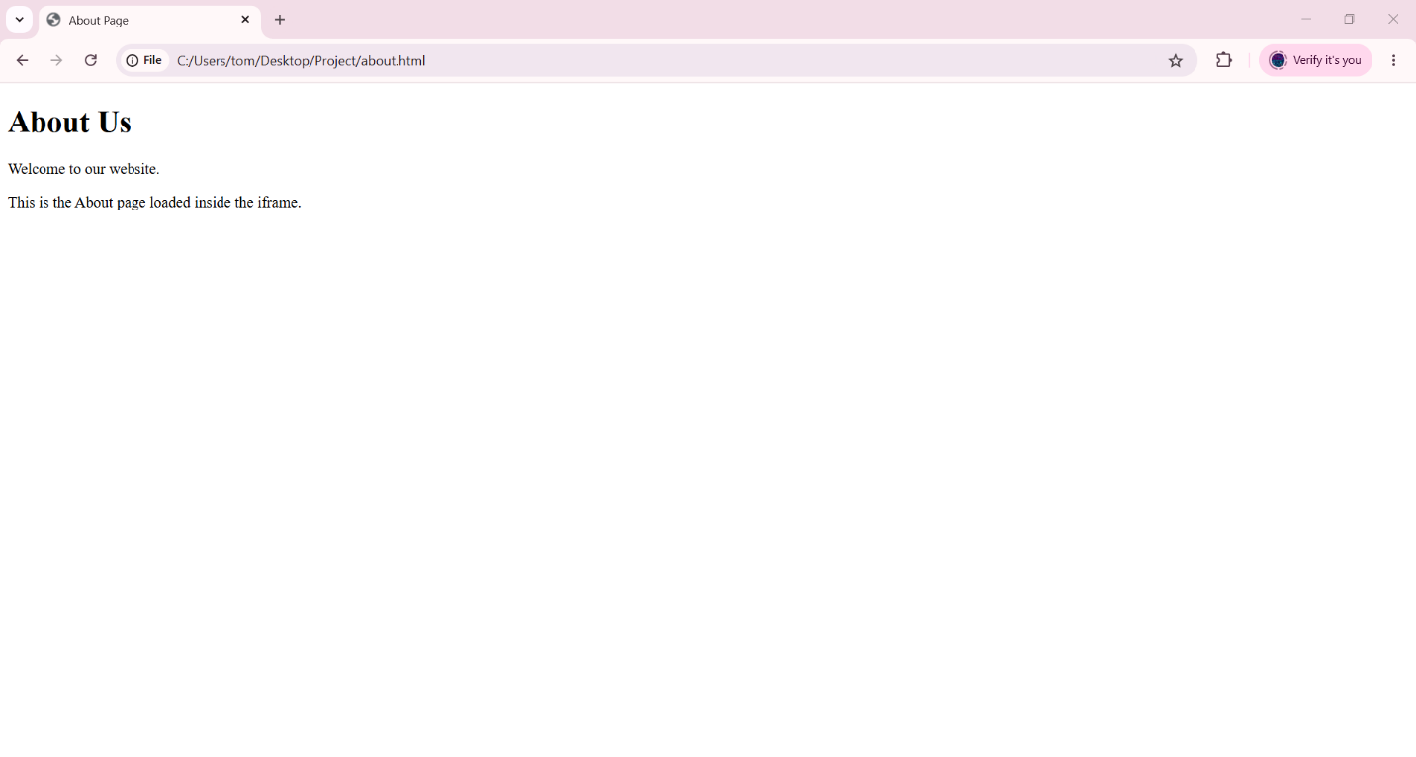

Index.html
# Source: ScreenShot Source: Provided by: [Persons Table -> ID Column: 1, Name_En Column: Motasem Essam] -> Tool: [Automation Table -> ID Column: 16, Name_En Column: Screen Capture] -> From [Operating System: Windows] on [5/6/2026]
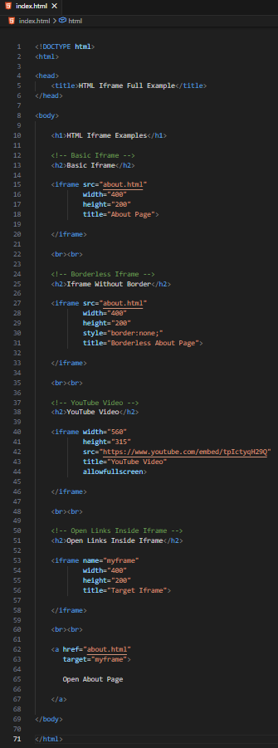
<!DOCTYPE html>
<html>

<head>
<title>HTML Iframe Full Example</title>
</head>

<body>

<h1>HTML Iframe Examples</h1>

<!-- Basic Iframe -->
<h2>Basic Iframe</h2>

<iframe src="about.html"
width="400"
height="200"
title="About Page">

</iframe>

<br><br>

<!-- Borderless Iframe -->
<h2>Iframe Without Border</h2>

<iframe src="about.html"
width="400"
height="200"
style="border:none;"
title="Borderless About Page">

</iframe>

<br><br>

<!-- YouTube Video -->
<h2>YouTube Video</h2>

<iframe width="560"
height="315"
src="https://www.youtube.com/embed/tpIctyqH29Q"
title="YouTube Video"
allowfullscreen>

</iframe>

<br><br>

<!-- Open Links Inside Iframe -->
<h2>Open Links Inside Iframe</h2>

<iframe name="myframe"
width="400"
height="200"
title="Target Iframe">

</iframe>

<br><br>

<a href="about.html"
target="myframe">

Open About Page

</a>

</body>

</html>

# Source: GIF Source: Provided by: [Persons Table -> ID Column: 1, Name_En Column: Motasem Essam] -> Tool: [Automation Table -> ID Column: 17, Name_En Column: GIF Recorder] -> From [Operating System: Windows] on [5/6/2026]
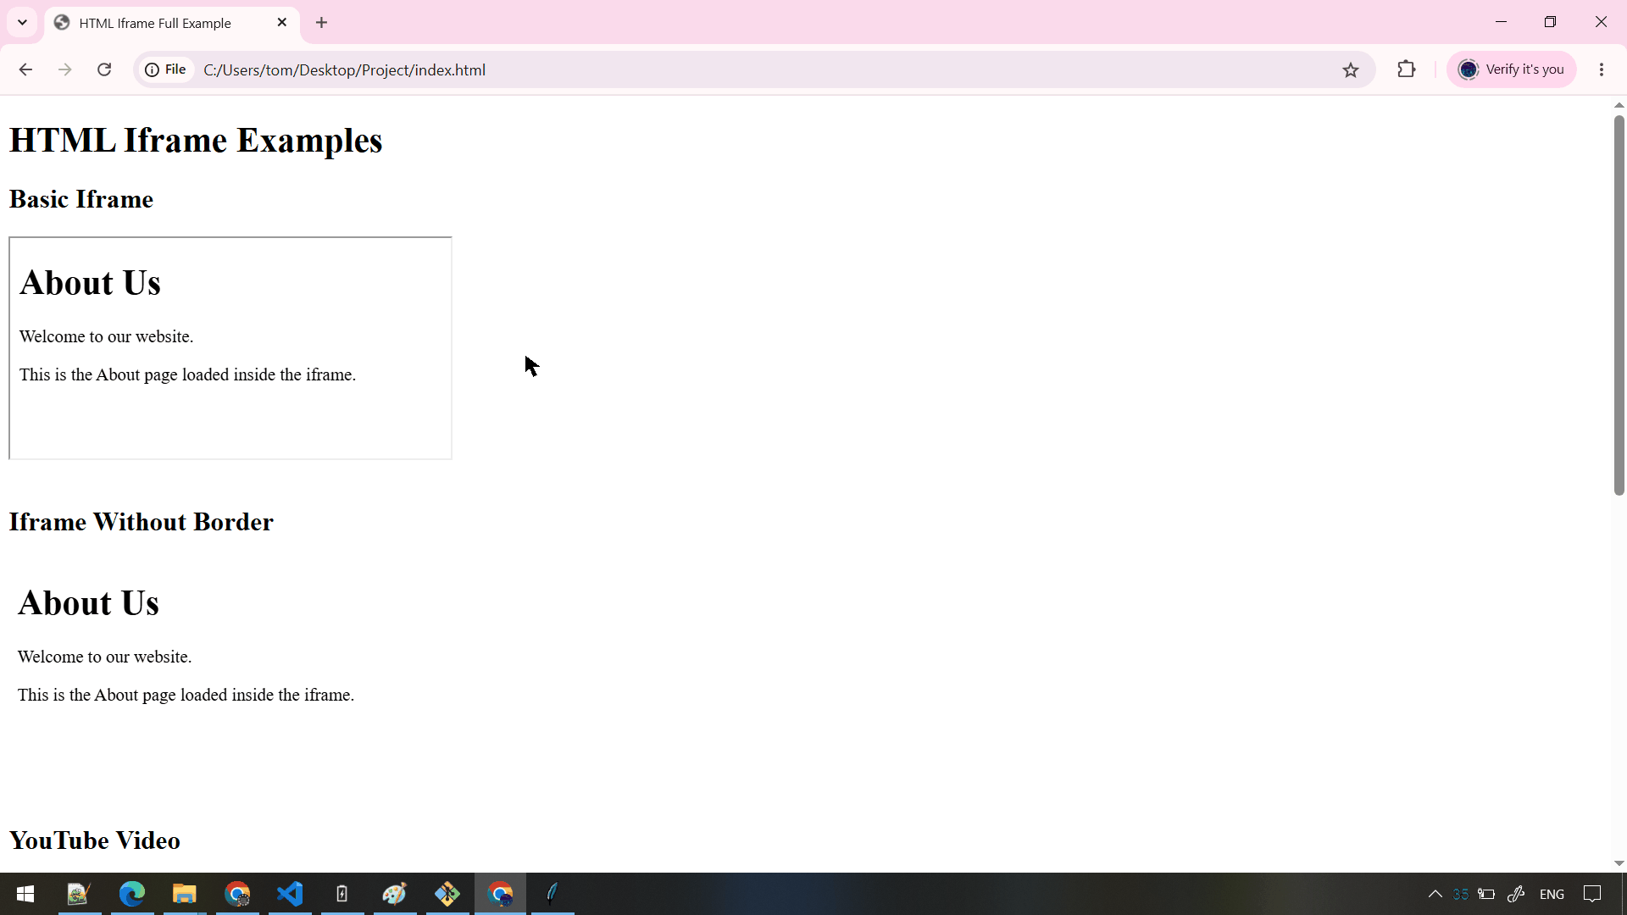

🧪 What You Can Test
# Source: AI Source: Provided by: [Data Path: Persons Table -> ID Column: 1, Name_En Column: Motasem Essam] -> From: [ChatGPT] on [5/6/2026]
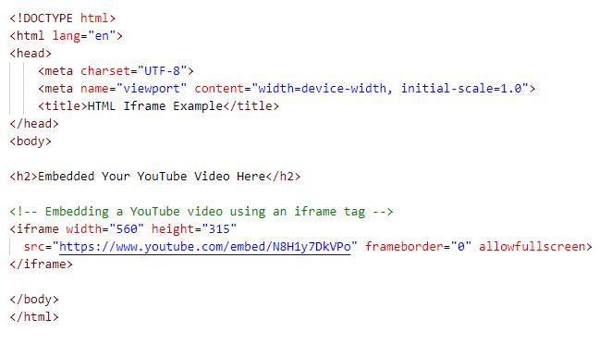
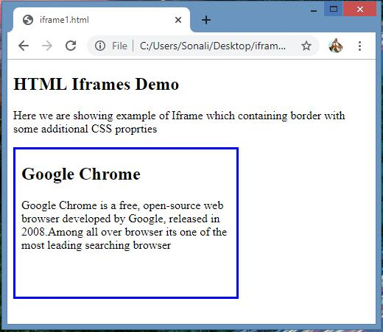
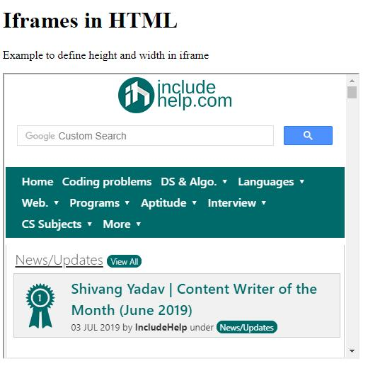
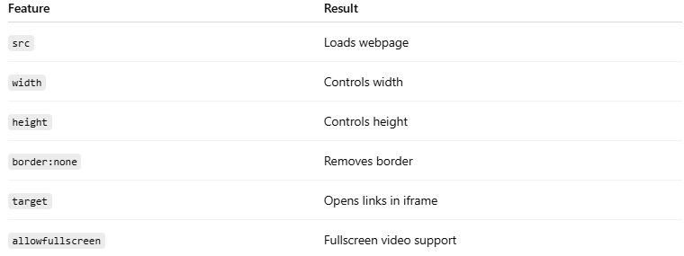
Feature | Result
src | Loads webpage
width | Controls width
height | Controls height
border:none | Removes border
target | Opens links in iframe
allowfullscreen | Fullscreen video support

⚠️ Important Notes

✅ Use title for accessibility
# Source: AI Source: Provided by: [Data Path: Persons Table -> ID Column: 1, Name_En Column: Motasem Essam] -> From: [ChatGPT] on [5/6/2026]
💻 Example:
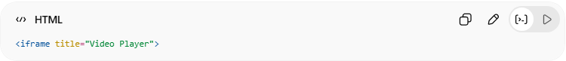
<iframe title="Video Player">

✅ Iframes can embed external websites
# Source: AI Source: Provided by: [Data Path: Persons Table -> ID Column: 1, Name_En Column: Motasem Essam] -> From: [ChatGPT] on [5/6/2026]
👉 But some websites block embedding for security

❌ Too many iframes can slow webpages
# Source: AI Source: Provided by: [Data Path: Persons Table -> ID Column: 1, Name_En Column: Motasem Essam] -> From: [ChatGPT] on [5/6/2026]
👉 Use carefully

❌ Some browsers/security settings may restrict iframes
# Source: AI Source: Provided by: [Data Path: Persons Table -> ID Column: 1, Name_En Column: Motasem Essam] -> From: [ChatGPT] on [5/6/2026]
👉 Especially cross-origin websites

🚀 In short:
# Source: AI Source: Provided by: [Data Path: Persons Table -> ID Column: 1, Name_En Column: Motasem Essam] -> From: [ChatGPT] on [5/6/2026]
The HTML <iframe> element embeds webpages, videos, maps, and documents inside another webpage using an inline frame.

